Blog system detailed design

***Team member:***

Liu Tong

Zeng Kete

Li Pengfei

Liu Zhefeng

**Table of Contents**

•Introduction

•Project Overview

•Structure Overview

•Module and Interface Description

•Implementation Plan

•Risk assessment

•Conclusion

•References

# Introduction

In the SHMUBlog Project a system has to be designed to support Internet communicating system. The system to be made consists of at least four main functions, which must interact the internet. The system has two actors. The user may involve the basic activities, such as user sign in, article publishing, knowledge sharing and social communicating activities. The administrator may manage user information, review articles ...The entire system has to be developed(in Python) in a way that it is easy to maintain and extend. The purpose of this system is to write a log, express their feeling about everything, share learning experience and communicate.

# Project Overview

Blog is usually called Web Log, as a popular way of communication on the Internet, it mainly provides a platform for users to simple, fast and convenient to publish their own experience, timely and easily communicate with others. Blog is after Email, BBS, ICQ after the emergence of the fourth kind of network communication, has been very popular with everyone, but also represents a new way of learning,communicate. Users can register in this system to apply for their own blog. Once users have applied for their own blogs, they can post their feelings and experiences on their blogs. When they post their articles, visitors can comment on the content of the logs published by users. Users can publish articles, pictures and messages on the blog to communicate with others.

# Structure Overview

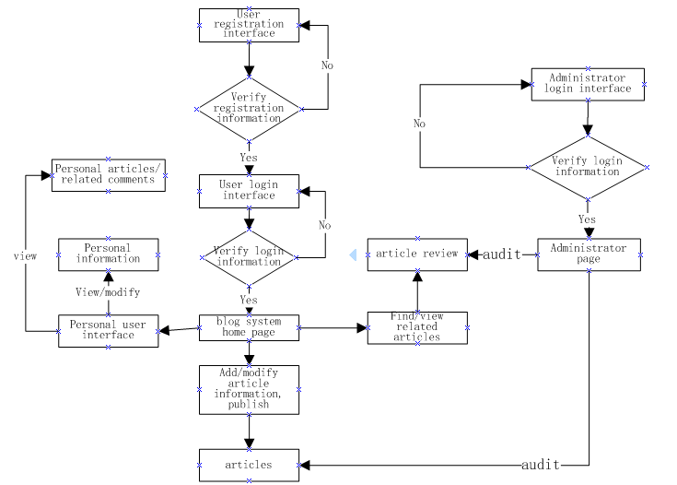

# Module and Interface Description

# Our project will be using Flask framework.Flask is a lightweight [WSGI](https://wsgi.readthedocs.io/) web application framework. It is designed to make getting started quick and easy, with the ability to scale up to complex applications. It began as a simple wrapper around [Werkzeug](https://www.palletsprojects.com/p/werkzeug/) and [Jinja](https://www.palletsprojects.com/p/jinja/) and has become one of the most popular Python web application frameworks.

# Flask offers suggestions, but doesn’t enforce any dependencies or project layout. It is up to the developer to choose the tools and libraries they want to use. There are many extensions provided by the community that make adding new functionality easy.

**1.Adminstrator Module**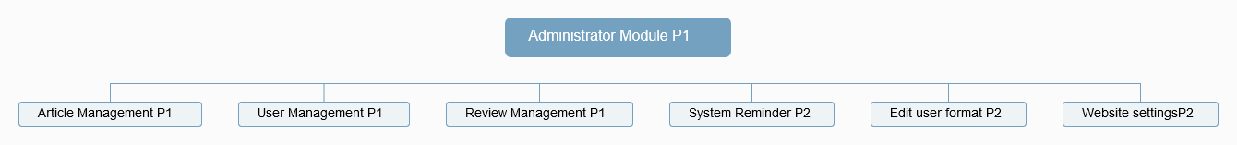The administrator module can provide article management, user management, comment management, system reminder, edit user information, website settings and other functions.

## 2.Home Page

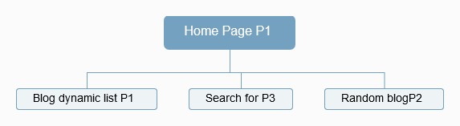

On the home page, the blog list can be dynamically displayed, and then the user can be provided with a search function, and the blog post can be automatically recommended according to the user's interest.

## 3.User Authentication

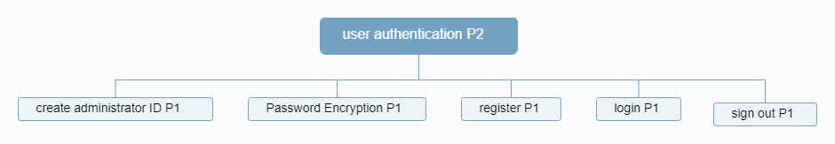

There are five fundamental functions. User authentication includes creating administrator id , password encryption, registering, login and signing out. These functions are easy to use for user and Administrator.

## 4.Blog background management

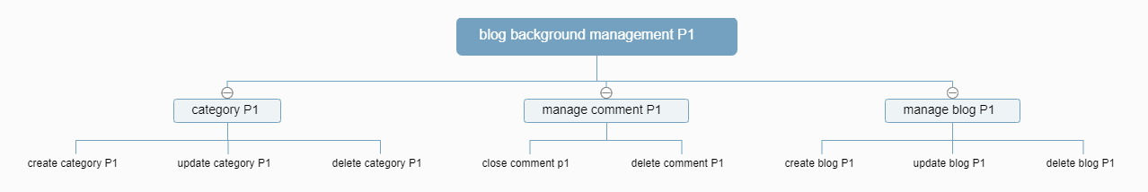

Administrator and user can manage category ,comment and blog.The category clearly could be created ,updated and deleted. And they can close comment and delete comment. They also can create blog ,update blog and delete blog.

## 5.User Module

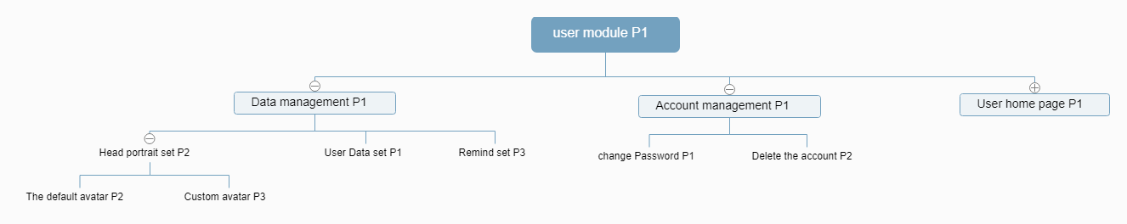

Realize the user's personal information, user account, user home page management. users can set personal portrait, personal information, when there is a new message, the system will provide a reminder function.Users can change the account password or delete the account directly.Under the user's home page, the current user's followers and followers as well as the user's favorite articles will be displayed. Moreover, when the user gets new followers, the system will remind the current user.

## 6.Blog Home Page

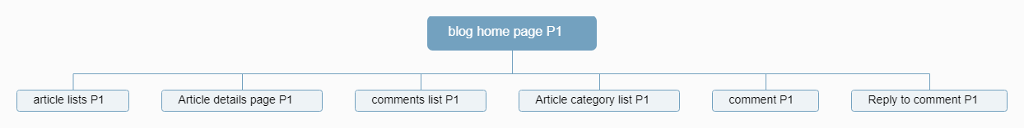

The home page of the blog will provide a list of all the articles published by the user. The user can set a list for the classification management of the articles. The user can comment on the articles or reply to the comments of others.Your own comments and others' comments about you and your articles will be displayed on this page.After the user clicks on the article, the system will enter the detailed page of the article to view the specific information of the article.

# Implementation Plan

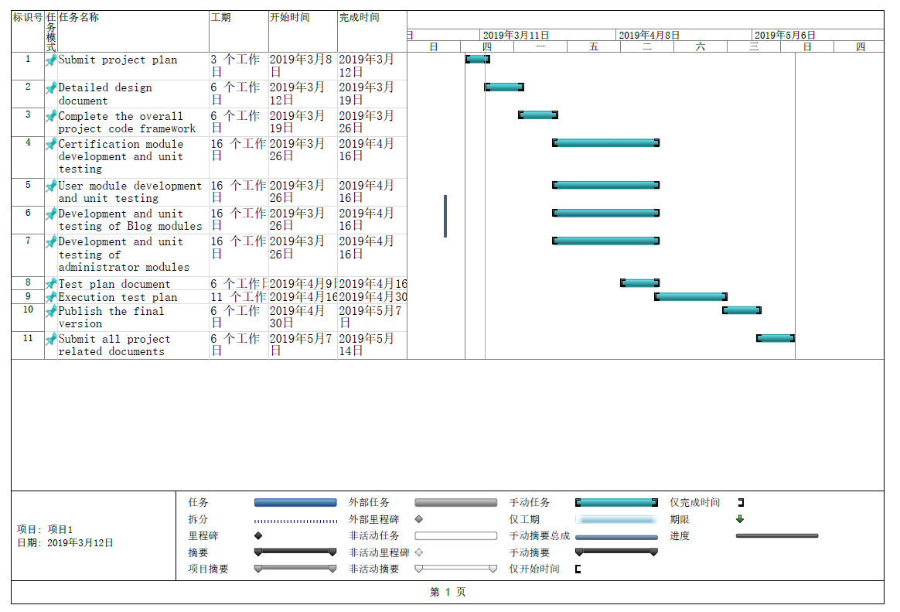

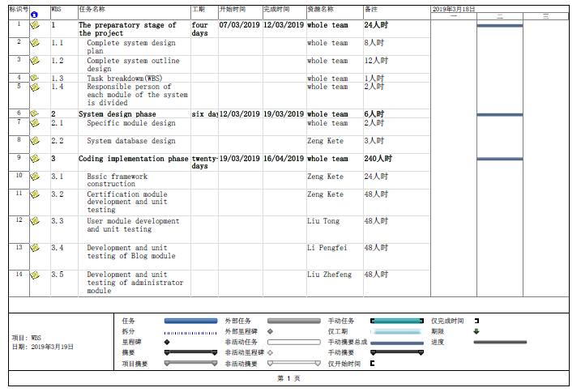

# Risk assessment and responsibility

**Risk assessment**

1. Time constraints or staff illness have caused the system to fail to deliver on schedule
2. Whether the technical means of software implementation can meet the performance requirements at the same time
3. The ability of the system to adapt to different working environments

**Responsibility analysis of project participants**

**The project manager**：Zeng Kete

**The main responsibility**: Participate in coding and documents and control the progress and overall situation

**Other project participants**:Li Peng Fei, Liu Tong, Liu Zhefeng

**The main responsibility**: All documents and codes

# Conclusion

As a team, we feel that this project has great potential to very useful to our user.It will enable them to more effectively communicate and learn each other, and thus making a large impact in their life. This project consists of two main actors: User and Administrator. And the Flask framework , Jinjia2 makes it easy to design and implement.In the end ,we will improve this system all the way.

# References

<http://naotu.baidu.com/file/>

<https://translate.google.cn/>

<http://www.doc88.com/>